Report by: 1409046  
Role: Level Design & Artist liaison

Game Version: Latest – with Menus  
Date Reported: 20/04/2016

QA Status: Passed

Severity: Minor

Priority: Low

Test Introduction:

The purpose of this test was to check that the clock keeping the time of the player would stop when the player reached the end zone. To test this, I placed the ship at the end of the track and pressed play.

Expected outcome:

Clock would disappear and register the time.

Actual outcome:

The time was registered in the console and displayed but the timer kept going after win canvas was displayed.

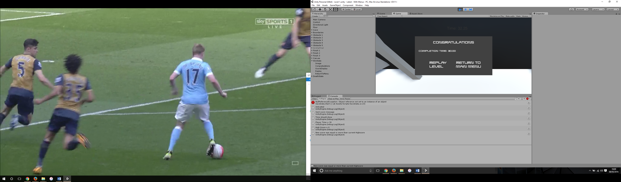Screenshot of the bug:

Image showing the timer still running when winstate is active.

Potential cause:

A potential cause for this bug could be that the script is never telling the clock to go away after winstate is achieved.

Suggested Fix:

This bug was outsourced to 1311941 as this was his original code, plus he knew how to turn it off quickly.